Ch15 Managing Global Systems

學習目標:

* 1. 哪些主要因素正在推動企業國際化？
  2. 發展全球業務的替代策略是什麼？
  3. 全球資訊系統面臨的挑戰是什麼？這些挑戰的管理解決方案？
  4. 開發國際資訊系統時應考慮哪些問題和技術替代方案？
* The Bel Group: Laughing All the Way to Success

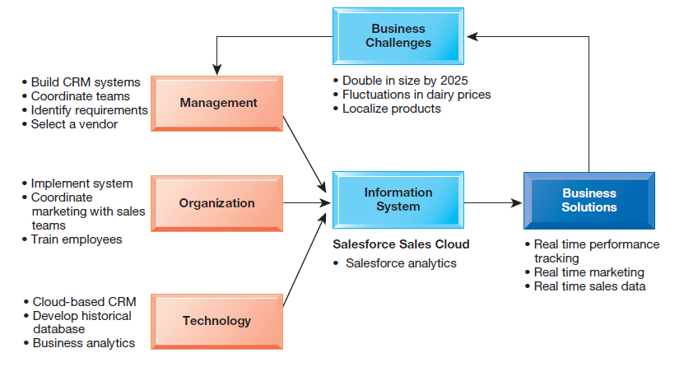

* How does information technology improve operations and decision making at the Bel Group? How would the company’s new CRM system facilitate its business strategy? Why is it important to incorporate the impact of a social media presence as a measurement tool?

1. What major factors are driving the internationalization of business?
   * Preface

* Global economic system and global world order driven by advanced networks and information systems
* Growth of international trade has radically altered domestic economies around the globe
* For example, production of many high-end electronic products parceled out to multiple countries
* For example: Apple iPhone’s global supply chain

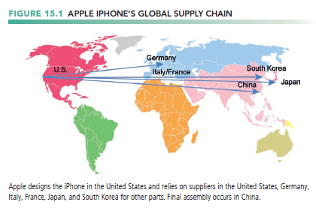

* + Developing an International Information Systems Architecture
* An international information systems architecture consists
* the basic information systems required by organizations to coordinate worldwide trade and other activities.
* Understand global environment.
* Business drivers for global competition
* inhibitors or negative factors that create management challenges
* Develop corporate strategy for global competition
* Develop organization structure and division of labor.
* Consider management issues
* Consider technology platform.

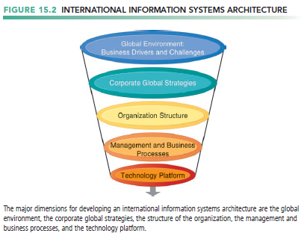

* + The Global Environment: Business Drivers and Challenges
* The global business drivers can be divided into two groups: general cultural factors and specific business factors

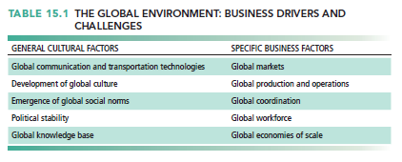

* General cultural challenges
* Cultural particularism
  + - Regionalism, nationalism, language differences
    - Brand-name expectations, work hours
    - Transborder data flow
    - Transborder data and privacy laws, commercial regulations
* Social expectations
* Political laws
  + - accounting practices
* Specific challenges
* Standards
  + - Different EDI, e-mail, telecommunication standards
* Reliability
  + - Phone networks not uniformly reliable
* Speed
  + - Different data transfer speeds, many slower than United States
* Personnel
  + - Shortages of skilled consultants
  + State of the Art
* Most companies have inherited a patchwork international system using traditional batch-oriented reporting, manual entry of data from one legacy system to another, and little online control and communication.
* Significant difficulties in building appropriate international architectures
* Planning a system appropriate to firm’s global strategy
* Structuring organization of systems and business units
* Solving implementation issues
* Choosing right technical platform

1. What are the alternative strategies for developing global businesses?
   * Preface

* Three organizational issues face corporations seeking a global position
* Choosing a strategy
* organizing the business
* organizing the systems management area.
  + Global Strategies and Business Organization
* Four main global strategies for global firms’ organizational structure
* Domestic exporter
  + - heavy centralization of corporate activities in the home country of origin
    - Nearly all international companies begin this way, and some move on to other forms
* Multinational (多國企業)
  + - concentrates financial management
    - a central home base while decentralizing production, sales, and marketing operations to units in other countries
    - The products and services on sale in different countries are adapted to suit local market conditions.
* Franchisers
  + - product is created, designed, financed, and initially produced in the home country
    - for product-specific reasons must rely heavily on foreign personnel for further production, marketing, and human resources.
* Transnational (跨國企業)
  + - the stateless, ruly globally managed firms
    - no single national headquarters but instead have many regional headquarters and perhaps a world headquarters.
    - managed from a global perspective without reference to national border
    - has been likened to a federal structure in which there is a strong central management core of decision making but considerable dispersal of power and financial muscle throughout the global divisions.
* Three main kinds of organizational structure
* Centralized: In the home country
* Decentralized/dispersed: To local foreign units
* Coordinated: All units participate as equals

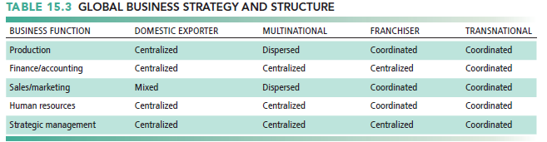

* + Global Systems to Fit the Strategy
* Configuration, management, and development of systems tend to follow global strategy chosen
* Four main types of systems configuration
* **Centralized**
  + - Systems development and operation occur totally at domestic home base
* **Duplicated**
  + - Development occurs at home base but operations are handed over to autonomous units in foreign locations
* **Decentralized:**
  + - Each foreign unit designs own solutions and systems
* **Networked**
  + - Development and operations occur in coordinated fashion across all units

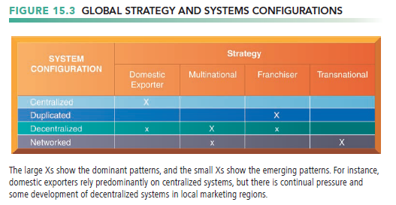

* + Reorganizing the Business
* To develop a global company and information systems support structure:
* Organize value-adding activities along lines of comparative advantage
  + - For example: Locate functions where they can best be performed, for least cost and maximum impact.
* Develop and operate systems units at each level of corporate activity—regional, national, and international.
* Establish at world headquarters
  + - Single office responsible for development of international systems
    - Global CIO position

1. What are the challenges posed by global information systems and management solutions for these challenges?
   * A Typical Scenario: Disorganization on a Global Scale

* Principle management challenges in developing global systems
* Agreeing on common user requirements
* Introducing changes in business processes
* Coordinating application development
* Coordinating software releases
* Encouraging local users to support global systems
* Traditional multinational consumer-goods company based in United States and operating in Europe would like to expand into Asia
* World headquarters and strategic management in United States
* Only centrally coordinated system is financial controls and reporting
* Separate regional, national production and marketing centers
* Foreign divisions have separate IT systems
* E-mail systems are incompatible
* Each production facility uses different ERP system, different hardware and database platforms, and so on
  + Global Systems Strategy
* Preface
* Share only core systems
  + - Core systems support functionality critical to firm
* Partially coordinate systems that share some key elements
  + - Do not have to be totally common across national boundaries
    - Local variation desirable
* Peripheral systems
  + - Need to suit local requirements only

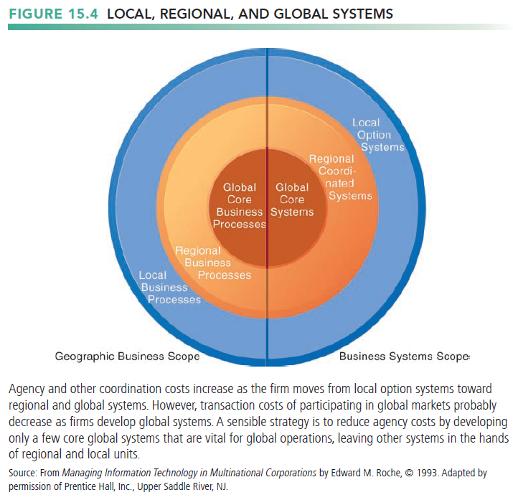

* + - 1. Define core business processes.
      2. Identify core systems to coordinate centrally.
      3. Choose an approach
    - Piecemeal and grand design approaches tend to fail.
    - Evolve transnational applications incrementally from existing applications. This is sometimes referred to as the “salami strategy,” or one slice at a time.

1. Make the Benefits Clear
   * + One of the worst situations to avoid is to build global systems for the sake of building global systems.
     + Global flexibility
     + Gains in efficiency
     + Global markets and larger customer base unleash new economies of scale at production facilities
     + Optimizing corporate funds over much larger capital base
   * The Management Solution: Implementation

* Agreeing on Common User Requirements
* Short list of core business processes
* Develop common language, understanding of common elements and unique local qualities
* Introducing Changes in Business Processes
* Success depends on legitimacy, authority, ability to involve users in change design process
* Legitimacy is defined as the extent to which your authority is accepted on grounds of competence, vision, or other qualities.
* The selection of a viable change strategy should assist you in convincing others that change is feasible and desirable.
* Involving people in change, assuring them that change is in the best interests of the company and their local units, is a key tactic.
* Coordinating Applications Development
* Coordinate change through incremental steps
* Reduce set of transnational systems to bare minimum to reduce coordination costs.
* Coordinating Software Releases
* Institute procedures to ensure all operating units update at same time
* Encouraging Local Users to Support Global Systems
* The key to this problem is to involve users in the creation of the design without giving up control over the development of the project to parochial interests.
* Cooptation: Bringing the opposition into design and implementation process without giving up control over direction and nature of the change
  + - Permit each country unit to develop one transnational application
    - develop new transnational centers of excellence, or a single center of excellence.
    - Centers of excellence perform the initial identification and specification of business processes, define the information requirements, perform the business and systems analysis, and accomplish all design and testing.

1. What are the issues and technical alternatives to be considered when developing international information systems?
   * Preface

* One major challenge is finding some way to standardize a global computing platform when there is so much variation from operating unit to operating unit and from country to country
* Another major challenge is finding specific software applications that are user-friendly and that truly enhance the productivity of international work teams.
  + Computing Platforms and Systems Integration
* How new core systems will fit in with existing suite of applications developed around globe by different divisions and different people and for different kinds of computing hardware.
* The goal
* develop global, distributed, and integrated systems to support digital business processes spanning national boundaries.
* having all sites use the same hardware and operating system does not guarantee integration
* Standardization: Data standards, interfaces, software, and so on
  + Connectivity
* Truly integrated global systems must have connectivity—the ability to link together the systems and people of a global firm into a single integrated network
* The public Internet does not guarantee any level of service

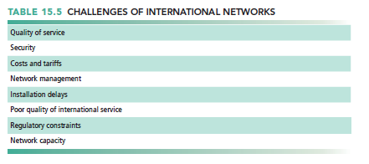

* Many firms use private networks and VPNs
* Low penetration of PCs, outdated infrastructures in developing countries

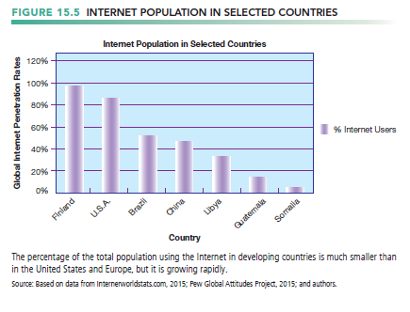

* many countries monitor transmissions.
  + Software Localization
* The development of core systems poses unique challenges for application software:
* Integrating new systems with old
* Entirely new interfaces must be built and tested if old systems are kept in local areas
* Software localization: converting software to operate in second language
* Most important software applications:
* TPS and MIS
* SCM, EDI, and enterprise systems
* Collaboration tools, e-mail, videoconferencing